**Java lesson one**

1. Create new HelloWorld project
   1. Add class named “Main” – be sure to check the “public static void main” checkbox
2. Create “Dog” class
   1. In Main, instantiate MyDog as a new Dog
3. Give the dog a “Bark” method
   1. In Main, have MyDog bark
4. In Main instantiate YourDog, and have it bark as well
5. Discussion on variables
6. Dog with "Name" public field (property)
   1. How to tell MyDog from YourDog
   2. Have the Dog say its Name before it barks
   3. In Main, give each Dog a name
7. Name in constructor
   1. Comment out one name, and run the program – what happens?
   2. Create a Constructor, and add name (lower case) as a parameter
   3. In Main, set each Dog’s name in the instantiation, commenting out the other set name
8. Name as private field
   1. Un-comment one of the set name lines, and change the name – what happens?
   2. Make the Name field private
9. Have program make decisions with “if”
   1. What happens when you have the Dog bark multiple times?
   2. Have the Dog bark only once, using an if statement
10. Make the Dog bark several times. Introducing several concepts:
    1. Overload the Bark method
    2. Use “for” loop
    3. Call another method
11. Difference between void and a return value
    1. Create “Add” method (function) and call it from Main

Apply what you’ve learned

1. Create a new project named "Animals" (make sure it's plural) with a “Main” class.
2. Create a class named "Cat".
   1. Cat will have a Name, which is required (same as Dog).
   2. Cat will have a CoatColor, which will also be required (hint: the Constructor can have multiple Parameters, separated by a comma).
   3. Cat will have a method named "Meow" (instead of Bark) – it doesn’t have to say its name.
      1. Since cats are independent-minded, we won't have them meow multiple times.
   4. Cat will have a method named "CatchMouse", which will respond with "I caught a mouse!"
   5. CatchMouse will be overloaded with a number of mice to be caught. Cat will respond with "I caught x mice!", where x is the number of mice to be caught. So if the Cat is asked to catch 5 mice, it will say "I caught 5 mice!" - it will NOT say "I caught a mouse" five times.
      1. If you want an extra challenge, have the Cat say "mouse" when the number to be caught is 1, and have it say "mice" with the number to be caught is greater than 1.
3. In the "Main" method of Animals.java, demonstrate all of the functionality of the Cat class.

HelloWorld Project Source Code

Main.java

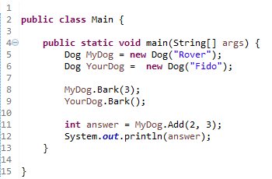

Dog.java

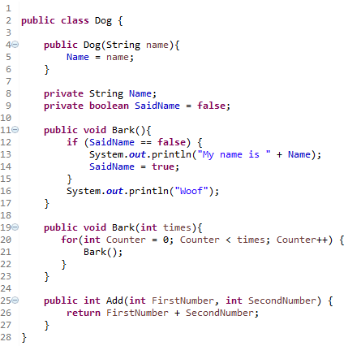

“Apply What You’ve Learned” Source Code

Main.java

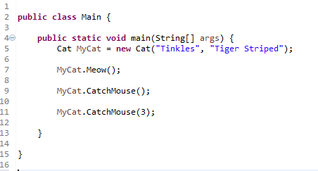

Cat.java

